NATIONAL BROKERS LIMITED
http://nationalbrokersbd.com/
Tea Auctioneers since 1948

TEA MARKET REPORT – Sale 14 held on Monday, 11th August, 2025

CTC LEAF: 54,162 packages of tea on offer met with a fair demand which slackened as the sale progressed.

BROKENS: Large Brokens met with fair interest but prices were easier than last. Smaller Brokens were fairly well supported at around last levels with only a few lines tending dearer. Plain teas once again met with a discriminating market and there were many withdrawals. BLF teas continued to meet with quite a good demand but there were more withdrawals this week.
FANNINGS: Good liquoring Fannings were in fairly good demand but were easier towards the end. Medium and plain types continued to meet with a discriminating market and prices dropped further with more withdrawals. BLF teas continued to meet with quite a good demand but there were more withdrawals this week.

DUST: 13,541 packages of tea on offer met with a fair demand with more withdrawals than last. Good liquoring Dusts were sold at easier levels and had few withdrawals.. Mediums were also an easier market with Tk.5/- to Tk.8/- less than last. Plain and BLF Dusts were an easier market and saw fair withdrawals. Blenders lent strong support with fair interest from the Loose tea buyers.
COMMENTS: There was more tea on offer this week and initially there was fair competition for good liquoring types which were fairly firm but these eased further with the progress of sale. Blenders lent a good support but owing to less competition from the Loose tea buyers particularly from the latter half of the sale and rates declined steadily.
Dusts were again an easier market.
Our Catalogue: (Sale 14) Avg : Tk 247.12, Sold 70.58% , (Sale 13) Avg : Tk 249.74 , Sold 73.15%

Quotations – This Week – (In Taka)
Exchange Rates 11th August, 2025 Sterling Pound 1617182 Dollar: Tk. 121.1000
Brokens | This Week | Last Week | Fannings | This week | Last Week | Dust | This week | Last Week
Best | 255-260 | 255-265 | Best | 250-255 | 250-260 | PD | 245-280 | 245-276
Good | 248-253 | 250-254 | Good | 246-249 | 248-250 | RD | 245-330 | 215-337
Medium | 246-248 | 247-250 | Medium/  Plain | 245-247 | 246-247 | D | 245-350 | 218-273
Plain | 245 | 245 | Medium/  Plain | 245-247 | 245 | CD | 220-289 | 247-345
BLF | 185-220 | 185-220 | BLF | 185-224 | 170-225 | BLF | 220 | 215-232
Top Prices – This Week
Category – CTC | Garden | Grade |  | Package | Price | Buyer(s)
Brokens | Ruthna |  | BOP(S) | 10 | 376/- | GT
Fannings | Ruthna |  | OF | 10 | 332/- | Shati
Clonal Brokens | Kedarpur/Ruthna |  | GBOP(BT1)/GBOP | 20 | 345/- | AKT/Shati
Clonal Fannings | * Madhupur |  | PF(BT1) | 20 | 336/- | Ali/AKT
PD/RD | Ruthna |  | RD | 10 | 300/- | Shawon
Clonal PD/RD | * Madhupur |  | RD(BT1) | 10 | 330/- | AKT
D | * Monipur |  | D | 10 | 279/- | Ispahani
Clonal D | * Madhupur |  | D(BT1) | 10 | 350/- | Shawon
CD | Ruthna |  | CD | 10 | 294/- | AL-Amin
Clonal CD | Kaiyacherra Dalu |  | CD | 10 | 310/- | Mintu
* Above price(s) realised in our catalogue

Offerings
This Sale (Sale 14) Next Sale (Sale 15) Season 2025-26 Season 2024-25 Season 2025-26 Season 2024-25
Type | Packages | Qty/Kg | Packages | Qty/Kg | Packages | Qty/Kg | Packages | Qty/Kg
Leaf | 54,162 | 2,702,683.8 | 65,716 | 3,279,228.4 | 51,058 | 2,547,794.2 | 45,763 | 2,283,573.7
Dust | 13,541 | 675,695.9 | 14,045 | 700,845.5 | 13,219 | 659,628.1 | 11,072 | 552,492.8
Total | 67,703 | 3,378,379.7 | 79,761 | 3,980,073.9 | 64,277 | 3,207,422.3 | 56,835 | 2,836,066.5

Chittagong Auction Average - Sale 13
(Season 2025/26): Tk 236.26 & (Season 2024/25): Tk 204.24 & (Season 2023/24) :Tk 208.58

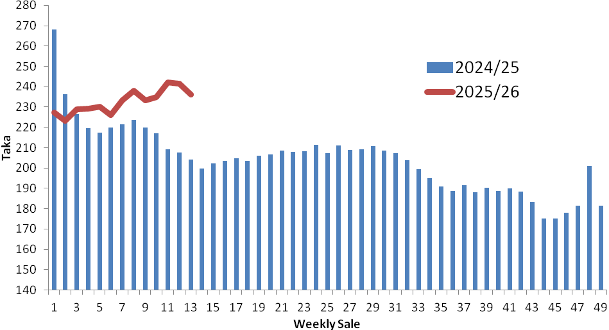

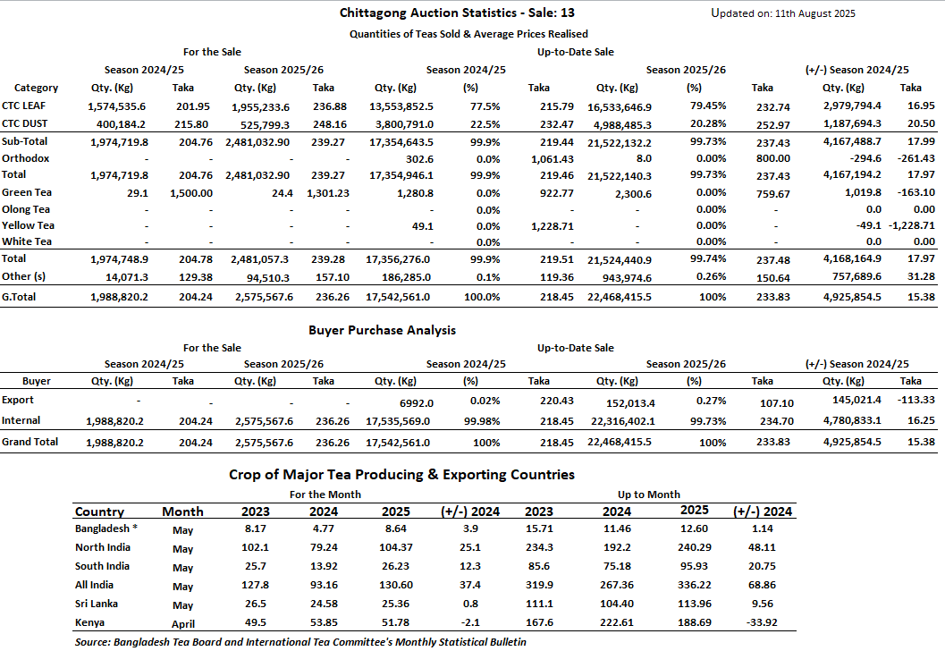

OTHER MARKETS

KOLKATA SALE 32- 5th 6th & 7th AUGUST, 2025
There was good demand. Best and good liquoring Assams saw a decline in levels and were easier, especially the fannings. Medium Assams were barely steady to irregularly easier. Dooars continued to be easier, whilst plainer Dooars witnessed withdrawals due to lack of suitable bids. Dust: Good Demand. Good liquoring Assams were irregularly easier. The remainder followed a similar trend. Western India buyers and Hindustan Unilever were active in both segments, primarily on brighter liquoring Assams. M/s Tata Consumer Product Limited showed some interest on plainer Dooars. Local buyers operated on grainy, clean teas. Exporters operated on bolder brokens.
Tea Category | Price Range (USC/kg)
BEST ASSAMS | 388-457
GOOD ASSAMS | 297-366
MEDIUM ASSAMS | 171-240
GOOD DOOARS | 297-320
MEDIUM DOOARS | 183-263
PLAINER DOOARS | 114-149
COONOOR SALE 32- 8th AUGUST,2025
The total CTC leaf teas sold this week was 77.08%(1269231.05kgs) of the total offering of 1646701.52Kgs DEMAND: - Good demand. MARKET: - Erratic price pattern continues to persist on the best, good & better medium category teas with irregular prices closely following quality. Better medium teas sold at firm to dearer prices especially on some select medium broken. Medium sorts continue to sell at steady levels. Plainer sorts were barely steady to dearer especially on the blacker types. BUYING PATTERN: - Major blenders along with the Western India packer lent fair support. Major blenders picked up50.05%of the CTC Leaf sold. Local & regional packers continue to be active on the best and good liquoring sorts. Internal buyers were once again choosy. Russian and CIS exporters along with the Middle east shippers continued to be active. Iraqi shippers were fairly active.
CTC  Leaf(USC/KG) | Best | Good | Better Medium | Medium | Plain
Larger Brokens | 201 | 149-174 | 102-126 | 95-101 | 81-94
Medium Brokens | 213-280 | 153-207 | 104-120 | 95-104 | 86-94
Smaller Brokens | 232-287 | 177-184 | 104-118 | 95-104 | 83-94
Fannings | 206-258 | 177-202 | 109-155 | 91-107 | 80-89

MOMBASA SALE 31- 4th & 5th AUGUST, 2025
There was fair demand for the 164,390 packages (11,151,998.00 kilos) available in the market with 41.03% unsold
CTC QUOTATIONS | BP1 – USC | PF1 – USC | PD – USC | D1 – USC
Best | 270 – 540 | 296 – 357 | 250 – 322 | 270 – 372
Good | 250 – 306 | 280 – 325 | 250 – 301 | 264 – 301
Good Medium | 230 – 323 | 284 – 311 | 250 – 276 | 259 – 320
Medium (KTDA) | 170 – 202 | 170 – 262 | 180 – 231 | 180 – 266
Medium (Plantations) | 157 – 211 | 170 – 202 | 150 – 184 | 159 – 181
Lower Medium | 126 – 166 | 128 – 178 | 127 – 171 | 127 – 164
Plainer | 090 – 130 | 080 – 124 | 082 – 127 | 089 – 124

